National University of Computer and Emerging Sciences



AL-2002: Artificial Intelligence Lab
Lab Manual 13

Department of Computer Science
FAST-NU, Lahore, Pakistan

Table of Contents
Objectives 3
1 Introduction 3
1.1 Underfitting 3
1.2 Overfitting 3
2 Learning Curves 4
3 K-Fold Cross Validation 8
4 Early Stopping 11
5 Dropout 12
6 When to use what 13

Objectives
After performing this lab, students shall be able to:
- Understand the concepts of overfitting and underfitting
- Interpret learning curves
- Apply k-fold cross-validation
- Understand and implement early stopping
- Understand dropout and its role in regularization
- Improve model performance and generalization

Introduction
In machine learning, building a model is not just about achieving high accuracy on training data. A good model should generalize well to unseen data.
Two common problems arise during training:
- Overfitting: Model performs well on training data but poorly on new data
- Underfitting: Model fails to capture patterns even in training data
To address these issues, several techniques are used, including:
- Learning curves
- Cross-validation
- Regularization (dropout)
- Early stopping
- Hyperparameter tuning

Underfitting
Underfitting occurs when the model is too simple to learn the underlying patterns.

Characteristics:
- Low training accuracy
- Low validation accuracy
- Model cannot capture relationships

Example Causes:
- Model too simple
- Insufficient training
- Poor feature selection

Overfitting
Overfitting occurs when the model learns noise instead of patterns.
Characteristics:
- Very high training accuracy
- Low validation accuracy
- Poor generalization
Example Causes:
- Model too complex
- Too many parameters
- Small dataset

Learning Curves
Learning curves help visualize model performance over time.
They plot:
- Training loss (or accuracy)
- Validation loss (or accuracy)
For example:
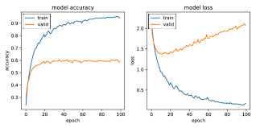

Scenario | Training Error | Validation Error | Meaning
Underfitting | High | High | Model too simple
Good Fit | Low | Low | Ideal
Overfitting | Low | High | Model too complex
Simple learning curves can be plotted as follows:
import matplotlib.pyplot as plt
epochs = [1,2,3,4,5]
train_loss = [0.9, 0.7, 0.5, 0.3, 0.2]
val_loss = [0.95, 0.8, 0.75, 0.78, 0.85]

plt.plot(epochs, train_loss, label="Training Loss")
plt.plot(epochs, val_loss, label="Validation Loss")

plt.xlabel("Epochs")
plt.ylabel("Loss")
plt.title("Learning Curve")
plt.legend()
plt.show()

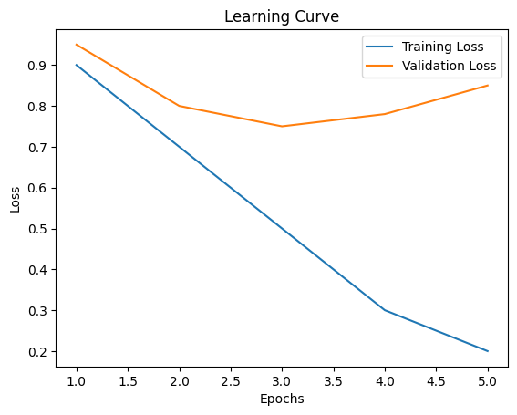
While using tensorflow, you can simply extract this loss. Consider the example given below:
Model Training
import tensorflow as tf
import numpy as np
import matplotlib.pyplot as plt

# -------------------------------
# 1. Generate Sample Dataset
# -------------------------------
# Create random input features
x = np.random.rand(1000, 10)

# Create binary labels based on a simple rule
y = (np.sum(x, axis=1) > 5).astype(int)

# -------------------------------
# 2. Build Neural Network Model
# -------------------------------
model = tf.keras.Sequential([
tf.keras.layers.Dense(64, activation='relu', input_shape=(10,)), # hidden layer
tf.keras.layers.Dense(32, activation='relu'), # hidden layer
tf.keras.layers.Dense(1, activation='sigmoid') # output layer
])

# -------------------------------
# 3. Compile Model
# -------------------------------
model.compile(
optimizer='adam',
loss='binary_crossentropy', # loss for binary classification
metrics=['accuracy'] # track accuracy
)

# -------------------------------
# 4. Train Model
# -------------------------------
history = model.fit(
x, y,
epochs=20,
batch_size=32,
validation_split=0.2, # 20% data used for validation
)
Learning Curves
# -------------------------------
# 5. Extract Learning Curves
# -------------------------------
train_loss = history.history['loss'] # training loss
val_loss = history.history['val_loss'] # validation loss
train_acc = history.history['accuracy'] # training accuracy
val_acc = history.history['val_accuracy'] # validation accuracy

# -------------------------------
# 6. Plot Loss Curve
# -------------------------------
plt.figure(figsize=(12, 5))

plt.subplot(1, 2, 1)
plt.plot(train_loss, label='Training Loss')
plt.plot(val_loss, label='Validation Loss')
plt.title('Training vs Validation Loss')
plt.xlabel('Epochs')
plt.ylabel('Loss')
plt.legend()
plt.grid(True)

# -------------------------------
# 7. Plot Accuracy Curve
# -------------------------------
plt.subplot(1, 2, 2)
plt.plot(train_acc, label='Training Accuracy')
plt.plot(val_acc, label='Validation Accuracy')
plt.title('Training vs Validation Accuracy')
plt.xlabel('Epochs')
plt.ylabel('Accuracy')
plt.legend()
plt.grid(True)

# -------------------------------
# 8. Display Plots
# -------------------------------
plt.tight_layout()
plt.show()
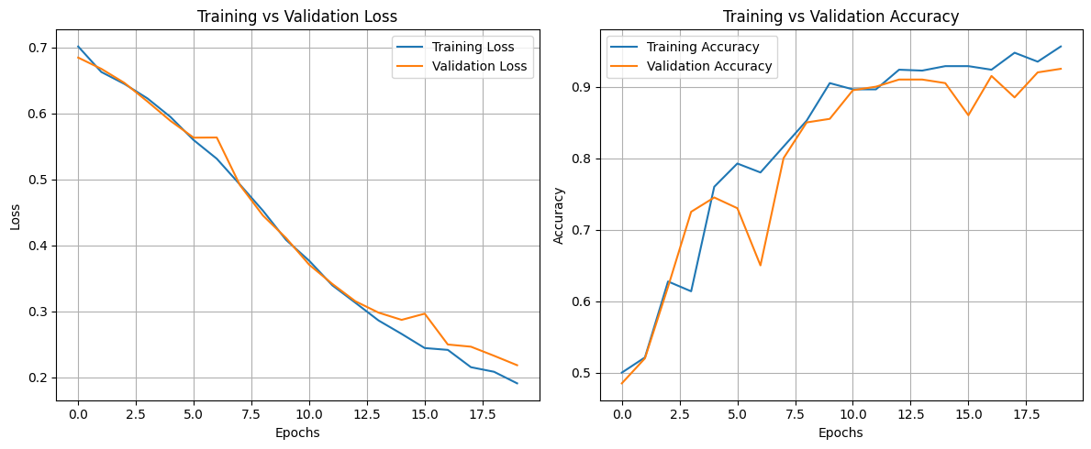

K-Fold Cross Validation

K-Fold Cross Validation is a statistical technique to measure the performance of a machine learning model by dividing the dataset into K subsets of equal size (folds). The model is trained on K − 1 folds and tested on the last fold. This process is repeated K times, with each fold being used as the testing set exactly once. The performance of the model is then averaged over all K iterations to provide a robust estimate of its generalization ability.

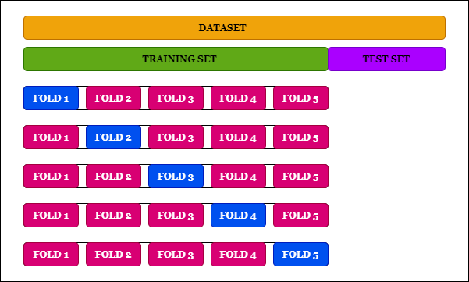
Cross-validation serves multiple purposes:

- Avoids Overfitting: Ensures that the model does not perform well only on the training data but generalizes to unseen data.
- Provides Robust Evaluation: Averages results over multiple iterations, reducing bias and variance in the performance metrics.
- Efficient Use of Data: Maximizes the utilization of the dataset, especially when the data size is limited.

A dataset can be divided into k folds using the KFold function from sklearn.model_selection

Using Scikit-learn

from sklearn.model_selection import KFold
from sklearn.linear_model import LogisticRegression
from sklearn.datasets import load_iris
from sklearn.metrics import accuracy_score

data = load_iris()
X, y = data.data, data.target

kf = KFold(n_splits=5)

model = LogisticRegression(max_iter=200)

scores = []

for train_index, test_index in kf.split(X):
X_train, X_test = X[train_index], X[test_index]
y_train, y_test = y[train_index], y[test_index]

model.fit(X_train, y_train)
predictions = model.predict(X_test)

scores.append(accuracy_score(y_test, predictions))

print("Cross-validation scores:", scores)
print("Average score:", sum(scores)/len(scores))

Using Tensorflow

import numpy as np
import tensorflow as tf
from sklearn.model_selection import KFold
from sklearn.datasets import load_iris
from sklearn.preprocessing import StandardScaler
from sklearn.metrics import accuracy_score

data = load_iris()
X, y = data.data, data.target

scaler = StandardScaler()
X = scaler.fit_transform(X)

kf = KFold(n_splits=5, shuffle=True, random_state=42)

scores = []
for train_index, test_index in kf.split(X):

X_train, X_test = X[train_index], X[test_index]
y_train, y_test = y[train_index], y[test_index]
model = tf.keras.Sequential([
tf.keras.layers.Dense(16, activation='relu', input_shape=(X.shape[1],)),
tf.keras.layers.Dense(8, activation='relu'),
tf.keras.layers.Dense(3, activation='softmax') # 3 classes in Iris
])
model.compile(
optimizer='adam',
loss='sparse_categorical_crossentropy',
metrics=['accuracy']
)
model.fit(X_train, y_train, epochs=30, batch_size=16, verbose=0)
loss, accuracy = model.evaluate(X_test, y_test, verbose=0)

scores.append(accuracy)

print("Cross-validation scores:", scores)
print("Average score:", np.mean(scores))

Early Stopping
Early stopping is a regularization technique that stops model training when overfitting signs appear. It prevents the model from performing well on the training set but underperforming on unseen data i.e validation set. Training stops when performance improves on the training set but degrades on the validation set, promoting better generalization while saving time and resources.
The technique monitors the model’s performance on both the training and validation sets. If the validation performance worsens, training stops and the model retains the best weights from the period of optimal validation performance.
Early stopping is an efficient method when training data is limited as it typically requires fewer epochs than other techniques. However, overusing early stopping can lead to overfitting the validation set itself, similar to overfitting the training set.
The number of training epochs is a hyperparameter that can be optimized for better performance through hyperparameter tuning.
Key Parameters in Early Stopping
- Patience: The number of epochs to wait for validation improvement before stopping, typically between 5 to 10 epochs.
- Monitor Metric: The metric to track during training, often validation loss or validation accuracy.
- Restore Best Weights: After stopping, the model reverts to the weights from the epoch with the best validation performance.
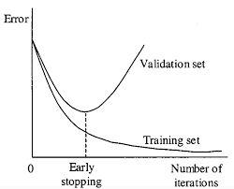

It can be added in tensorflow models using the following code:
early_stop = tf.keras.callbacks.EarlyStopping(
monitor='val_loss', # watch validation loss
patience=3, # wait 3 epochs before stopping
restore_best_weights=True
)
Once this callback has been defined, it can be simply added to the fit function.
history = model.fit(
x, y,
epochs=50, # large number (training may stop early)
batch_size=32,
validation_split=0.2,
callbacks=[early_stop], # apply early stopping
)

Dropout
The term "dropout" refers to dropping out the nodes (input and hidden layer) in a neural network. All the forward and backwards connections with a dropped node are temporarily removed, thus creating a new network architecture out of the parent network. The nodes are dropped by a dropout probability of p.
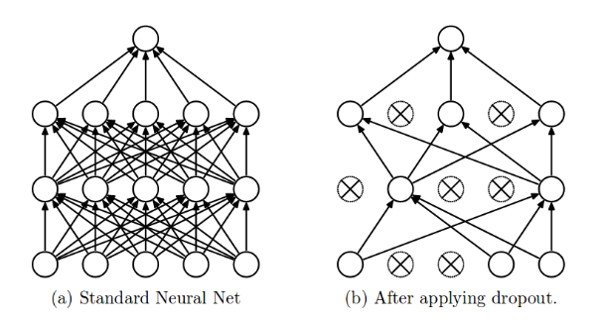
In the overfitting problem, the model learns statistical noise. To be precise, the main motive of training is to decrease the loss function, given all the units (neurons). So in overfitting, a unit may change in a way that fixes up the mistakes of the other units. This leads to complex co-adaptations, which in turn leads to the overfitting problem because this complex co-adaptation fails to generalise on the unseen dataset.
Now, if we use dropout, it prevents these units to fix up the mistake of other units, thus preventing co-adaptation, as in every iteration the presence of a unit is highly unreliable. So by randomly dropping a few units (nodes), it forces the layers to take more or less responsibility for the input by taking a probabilistic approach.
This ensures that the model is getting generalised and hence reducing the overfitting problem.
Dropout can be applied to a network using TensorFlow APIs as follows:

tf.keras.layers.Dropout(
rate
)
# rate: Float between 0 and 1.
# The fraction of the input units to drop.

Consider the example below:

model = tf.keras.Sequential([
tf.keras.layers.Dense(64, activation='relu', input_shape=(10,)),
tf.keras.layers.Dropout(0.5), # Drop 50% of neurons randomly
tf.keras.layers.Dense(32, activation='relu'),
tf.keras.layers.Dropout(0.3), # Drop 30% of neurons
tf.keras.layers.Dense(1, activation='sigmoid')
])

It can be incorporated by simply adding another layer in your ANN

When to use what

We explored different techniques to improve model performance and generalization. Each method plays a specific role depending on the problem observed during training.

Technique | When to Use | Problem Addressed | Key Idea
Learning Curves | During/after training to analyze performance | Diagnosis tool | Compare training vs validation trends
K-Fold Cross-Validation | When dataset is small or evaluation is unreliable | Poor generalization estimate | Train/test multiple times on different splits
Early Stopping | When validation performance starts degrading | Overfitting during training | Stop training at optimal point
Dropout | When model overfits (especially deep networks) | Overfitting | Randomly disable neurons to improve generalization

A good machine learning model is not the one that performs best on training data, but the one that generalizes well to unseen data. In practice, these techniques are often used together such as learning curves for diagnosis, cross-validation for evaluation and regularization methods like dropout and early stopping for improving performance.
Exercise Questions:
Question 1 — Detect Underfitting and Overfitting using Learning Curves
Create a binary classification dataset using NumPy and train a TensorFlow neural network model. Plot both training loss and validation loss curves for 20 epochs.
Tasks:
- Generate random input data with 10 features.
- Train an ANN model using TensorFlow.
- Extract training and validation loss from history.history.
- Plot learning curves using Matplotlib.
- Analyze whether the model shows:
- Underfitting
- Good Fit
- Overfitting

----------------------
Question 2 — Apply K-Fold Cross Validation using Scikit-learn
Use the Iris dataset and apply 5-Fold Cross Validation using LogisticRegression.
Tasks:
- Load the Iris dataset.
- Divide data into 5 folds using KFold.
- Train the model on each fold.
- Calculate accuracy for every iteration.
- Display:
- Accuracy of each fold
- Average cross-validation accuracy
----------------------
Question 3 — Implement Early Stopping in TensorFlow
Create a neural network model and apply Early Stopping to prevent overfitting.
Tasks:
- Generate a sample classification dataset.
- Build a TensorFlow ANN model.
- Add EarlyStopping callback with:
  - monitor='val_loss'
  - patience=3
  - restore_best_weights=True
- Train the model for 50 epochs.
- Observe at which epoch training stops automatically.

----------------------
Question 4 — Reduce Overfitting using Dropout Layers
Build two TensorFlow models:
- Model without Dropout
- Model with Dropout
Compare their performance using training and validation accuracy.
Tasks:
- Create a neural network without dropout.
- Create another network with:
  - Dropout(0.5)
  - Dropout(0.3)
- Train both models on the same dataset.
- Compare validation accuracy and overfitting behavior.

----------------------
Question 5 — Model Generalization using TensorFlow Techniques
Build and evaluate a TensorFlow classification model by applying multiple generalization techniques including Learning Curves, Early Stopping, Dropout, and K-Fold Cross Validation.
Tasks:
- Generate or load a classification dataset.
- Preprocess the dataset if required.
- Build an Artificial Neural Network (ANN) using TensorFlow.
- Add dropout layers in the neural network.
- Apply Early Stopping during training.
- Train the model and extract:
  - Training accuracy
  - Validation accuracy
- Plot training vs validation accuracy curves using Matplotlib.
- Apply 5-Fold Cross Validation to evaluate the model.
- Display:
  - Accuracy of each fold
  - Average cross-validation accuracy

- Analyze whether the model generalizes well or shows signs of overfitting/underfitting.

